|  |  |
| --- | --- |
| Project Team No: | **01** |
| Project Title: | **E - MEDICARE** |

Group 1 Team members:

1. ASasank Reddy
2. Aarthi Ellappan
3. Abburi Aruna
4. Abhilash M
5. Aditya Kumar
6. Akkamahadevi X
7. Akshay Kawade
8. Akshay X2
9. Amit Kumar
10. Amitkumar Rajanal

**ABSTRACT:**

Increasing advancement in technology can turn up for the good of the society and here we are planning to bring change in health care and services. The ultimate objective here is to design a E-Medicare Web Application that can perform medicine delivery with a much better secure system. E-Medicare Health management system is based on the web application which is used by the customer’s to buy the online medicines to avoid the transport . E-Health Care System project deals with Corporate Medicare Management. This project is very helpful to both Medicare staff as well as to the public. It is having mainly Administration and Client modules.

**Table of Contents**

1. INTRODUCTION…………………………………………………………..
2. OVERVIEW………………………………………………………………...
3. SUB-SYSTEM DETAILS…………………………………………………..
4. DATA ORGANIZATION…………………………………………………..
5. ASSUMPTIONS…………………………………………………………….
6. ADVANTAGES…………………………………………………………….
7. OUTPUT SCREENSHOTS OF MEDICARE………………………………
8. CONCLUSION……………………………………………………………...
9. **INTRODUCTION:**
   1. **INTRODUCTION:**

In Present scenario computer is an essential part for human life. It provides better Facilities for storage and retrieval of information related to different areas of application. The medical stores are looking for the services that are accurate and reliable for providing services to the customers. The detail of medicine which are available in medical store is easily managed and organized by using this system. The database for the customers can be managed by using this project.

The E-Medicare can be entered using a User Id and Password. It is accessible either by an administrator the data can be retrieved easily. In this Application we are going to provide online Medicine to the customer’s. Customers can find various types of medicine’s in this application the customer can buy the medicine at reasonable price. The User Interface is very user-friendly. The data are well protected for personal use and makes the data processing very fast.

The project E-Medicare includes registration of user/customer, storing their details into the system, and also computerized invoice. The software has the facility to give unique ID for every user/customer and stores the details of every customer automatically. User can search availability of product.

* 1. **Overview:**
     1. **Objective:**

The main objective of the project on E- Medicare Application is to manage the details of the customer, medicine company, medicine stock, order. It manages all the information about customers, payment, order, customer. The project is totally built at administrative end and thus only the administrator is guaranteed the access. The Purpose of the project is to build an application program to reduce the manual work or managing the customer, medicine company, payment, medicine. It tracks all the details about the medicine, medicine stock, order.

* + 1. **Scope of the Project**

1. To provide the better stock maintenance of the medicines.
2. Expiry Date of medicines
3. Keep track status of its medicine details.
4. To make Search for products based on the search keyword.
5. To sort results based on medicine categories.
6. To Add or remove medicine details from the application.
7. Edit medicine details like name, price, seller, and description to keep the product information updated with the current prices.
8. Enable or disable the medicines.

All this work is done manually by the admin and other Medicare staff. Admin have to remember various medicines available for customers.

1. **SYSTEM OVERVIEW:**
   1. **List of Modules for E-Medicare Management System:**

* **Admin Module:**

In this module we are going to add the products, delete the products, edit the products. Admin module allows system administrator to set up back-end of the system and perform basic system configuration, mainly definition of predefined drop-down fields, definition of classes time schedule, etc.

* **Login Module:**

The Login Module is a portal module that allows users to type a user name and password to log in. You can add this module on any module tab to allow users to log in to the system.

* **User Module:**

The user module allows users to register, log in, and log out. Users benefit from being able to sign on because this associates content they create with their account and allows various permissions to be set for their roles.

* **Search Module:**

Search modules provide functionality related to indexing and searching content on your site. The search module lets users search for specific product on site. You can search both for users and for particular words.

* **Cart Module:**

To buy the product and to remove the product if necessary.

* **Payment Module:**

It is used for managing the payment details. Payment module is group of payment features and setting, often made available by third party. These modules must be present in creating the E-Medicare Management to satisfy the needs in managing E-Medicare Web Application. Through this, the management and monitoring of products would be much easier for both admin and users.

* 1. **Requirement Specifications:**

**2.1.1 Introduction:**

To be used efficiently, all computer software needs certain hardware components or the other software resources to be present on a computer. These pre-requisites are known as (computer) system requirements and are often used as a guideline as opposed to an absolute rule. Most software defines two sets of system requirements: minimum and recommended. With increasing demand for higher processing power and resources in newer versions of software, system requirements tend to increase over time. Industry analysts suggest that this trend plays a bigger part in driving upgrades to existing computer systems than technological advancements.

**2.1.2 Hardware Requirements:**

The most common set of requirements defined by any operating system or software application is the physical computer resources, also known as hardware. A hardware requirements list is often accompanied by a hardware compatibility list, especially in case of operating systems. A hardware compatibility lists tested, compatibility and sometimes incompatible hardware devices for a particular operating system or application. The following sub-sections discuss the various aspects of hardware requirements.

**Hardware Requirements for Present Project:**

PROCESSOR : Intel dual Core i3

RAM : 1 GB

HARD DISK : 80 GB

**2.1.3 Software Requirements:**

Software Requirements deal with defining software resource requirements and pre-requisites that need to be installed on a computer to provide optimal functioning of an application. These requirements or pre-requisites are generally not included in the software installation package and need to be installed separately before the software is installed.

**Software Requirements for Present Project:**

The system will be developed on any Windows OS machine using J2EE, Hibernate and Spring.

* Server – Apache Tomcat 8 or higher Database – MySQL 8.0.28 or Higher.
* Eclipse IDE or Spring Tool Suite
* **AUTHENTICATION AND AUTHORIZATION:**

**Authentication:**

Every time we signed up, we likely been asked to create a username and password. Because this is such a common process now, it's become almost second-nature for some users to set up their accounts without much thought about the credentials they choose. And unfortunately, there's a lot at stake if a user chooses weak credentials.

**Authentication for User name and Password:**

When a user first signs up for website, they're asked to choose a username and password to identify themselves. In an ideal world, the user would always pick a strong and unique password so that it's harder for an attacker to guess.

**Password Rules:**

When it comes to password safety, the longer and more complex the password is, the better. We think its good practice to enforce certain minimum requirements when asking users to create a new password. Of course, you have to find a balance between these requirements and user experience. If you make the sign-up process too tedious, you could be driving users away. To enforce password strength, you should define a set of rules that a password must satisfy and then enforce these with form validation.

Example password strength rules:

* + - Minimum of 8 characters
    - At least one uppercase letter
    - At least one number
    - At least one special character

**Authorization:**

For Authorization, think of owning a E-Medicare page. When admin log in, since he owns the page. Hence, admin can post content on page, modify and add product content from admin and others of your page that are not administrators. User can’t modify or add product in the user page, user can only add the products to the cart and buy.

* **FUNCTIONAL FLOW:**

The functional flow of the messages across different application components is shown below.

Ex. - Web Application.

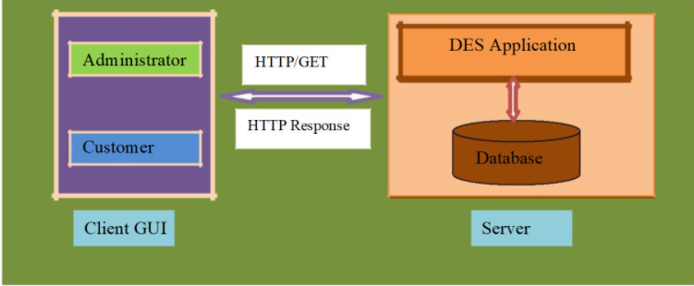

* **FUNCTIONAL SPECIFICATIONS:**

1. **Administrator:**

The administrator as a user is defined to perform below listed operations after successful login.

|  |  |  |  |
| --- | --- | --- | --- |
| Objects | Operations | Data to Include | Remarks |
| Product | Add, View, Delete , Modify | Product Name, Product Price |  |
| Customer | View | username, email, phone number, State, city, pin |  |
| Order and Purchase | View | User Id, Product Id, Product Price, Quantity, Price, Status (Pending or Placed) |  |

1. **Customer:**

The customer as a user is defined to perform below listed operations after successful login.

|  |  |  |  |
| --- | --- | --- | --- |
| **Objects** | **Operations** | **Data to Include** | **Remarks** |
| User | Register | UserId, Username, Password, Email, Phone Number, State, City, Pin etc. |  |
| Product | Add to Cart. Delete from Cart. Delete all products from cart. | Product Name, Price, Quantity, Status |  |
| Check out | Add User Details and Price | CartId, UserId and Total Price |  |

* 1. **Login or Logout:**
* Web Application – J2EE, Hibernate, Spring.
* Go to Registration screen when you click on Register link
* Go to Success screen when you login successfully after entering valid username & password fetched from the database.
* Redirect back to same login screen if username & password are not matching.
* Implement Session tracking for all logged in users before allowing access to application features. Anonymous users should be checked, unless explicitly mentioned.
  1. **Tables:**
     1. **User_Registration_Details:**

The user specific details such as username, email, phone etc. Authentication, and authorization / privileges should be kept in one or more tables, as necessary and applicable.

|  |  |
| --- | --- |
| **Field Name** | **Description** |
| User ID | User ID is auto generated after registration and it is used as Login ID. |
| Username | Username of the Customer. |
| Password | User Password |
| Phone Number | 10-digit contact number of user. |
| Address | Enter your address. |

* + 1. **Product_Details:**

This table contains information related to a product.

|  |  |
| --- | --- |
| **Field Name** | **Description** |
| Product Id | Unique Product Id, Here Product Id will be Primary Key. |
| Product Name | Name of the Product. |
| Product Price | Price of the Product. |

* + 1. **Product_Cart_Details:**

This table contains information related to cart details.

|  |  |
| --- | --- |
| **Field Name** | **Description** |
| Cart Id | Unique Cart ID Auto Generated |
| User Id | User Id corresponding to logged in user |
| Product Id | Product Id corresponding to product. |
| Product Price | Price of the Product |
| Quantity | Quantity of the product in e.g., 2 or 3 number of products |
| Total Price | Total price of the purchased products |
| Status | Product Availability Status, Example: Pending or Placed. |

* 1. **Case Diagram:**

Case Diagram is a visual representation of how a user might interact with a program. A use case diagram depicts the system’s numerous use cases and different sorts of users. The circles or ellipses are used to depict the use cases.

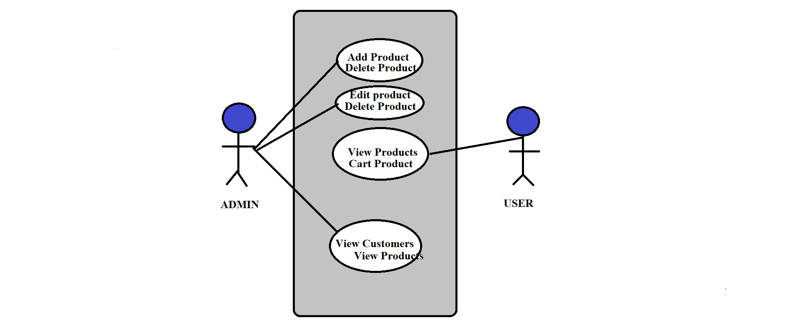

* 1. **ER Diagram:**

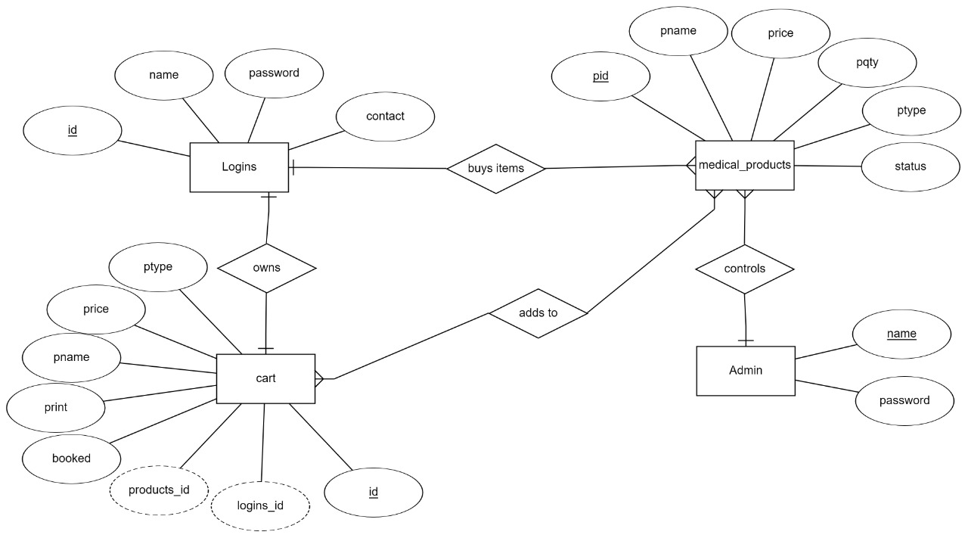

* 1. **Class Diagram:**

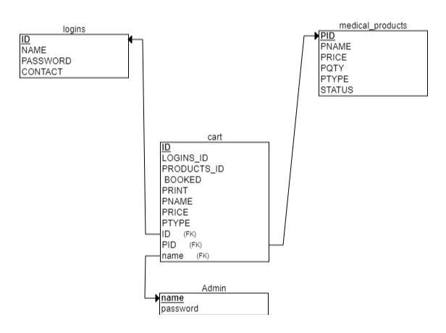

1. **SUB-SYSTEM DETAILS:**

The Digital Emporium E-Store System is defined, wherein all users need to login successfully before performing any of their respective operations.

Against each requirement, indicative data is listed in column ‘Data to include’. Further, suggested to add/modify more details wherever required with an approval from customer.

1. **DATA ORGANIZATION:**

This section explains the data storage requirements of the Product Order Entry System and indicative data description along with suggested table (database) structure. The following section explains few of the tables (fields) with description. However, in similar approach need to be considered for all other tables.

1. **ASSUMPTIONS:**

* User Interface: The type of client interface (front-end) to be supported - Angular based
* Each user (Admin and Customer) must have a valid user id and password
* The administrator can add and remove products into the databases
* When you add product into cart the No. of Products selected will be incremented
* If you remove the product from the cart, the counter will be decremented
* The total amount will be calculated based on the product, accordingly, change the product counter & total amount.

1. **ADVANTAGES:**

* Cost efficient
* Less time consuming
* Time-saving: Online pharmacy saves your time and efforts, in just a few minutes you can head over the E-Medicare website and buy any prescription medicine as per your need.
* It saves the time that you can spend in traveling to your local pharmacy shop and waiting in line for medicine.
* Anytime anywhere: You can place your order anytime from anywhere as there is no issue of pharmacy closing down.
* Easy Secured payments: Online pharmacy provides the facility of cashless payments either by credit or debit card, paytm or you can also pay by cash on delivery.

1. **OUTPUT SCREENSHOTS OF MEDICARE**
   1. **Home page:**

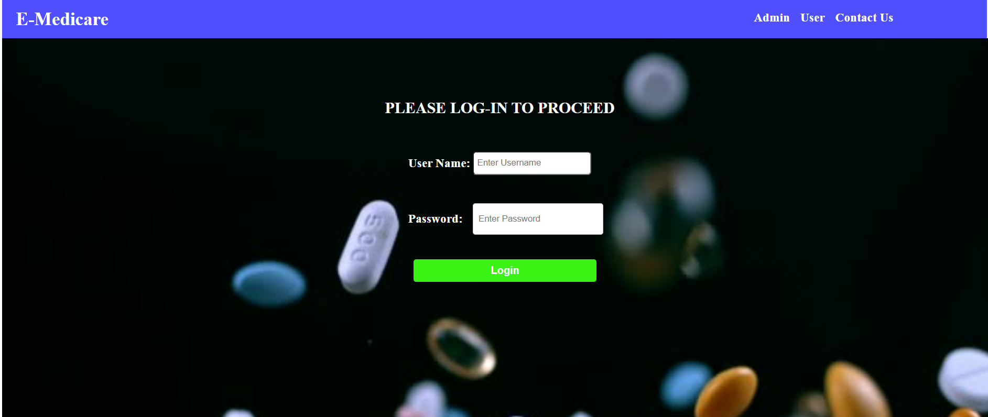

* 1. **Admin page:**



* 1. **Admin View product:**

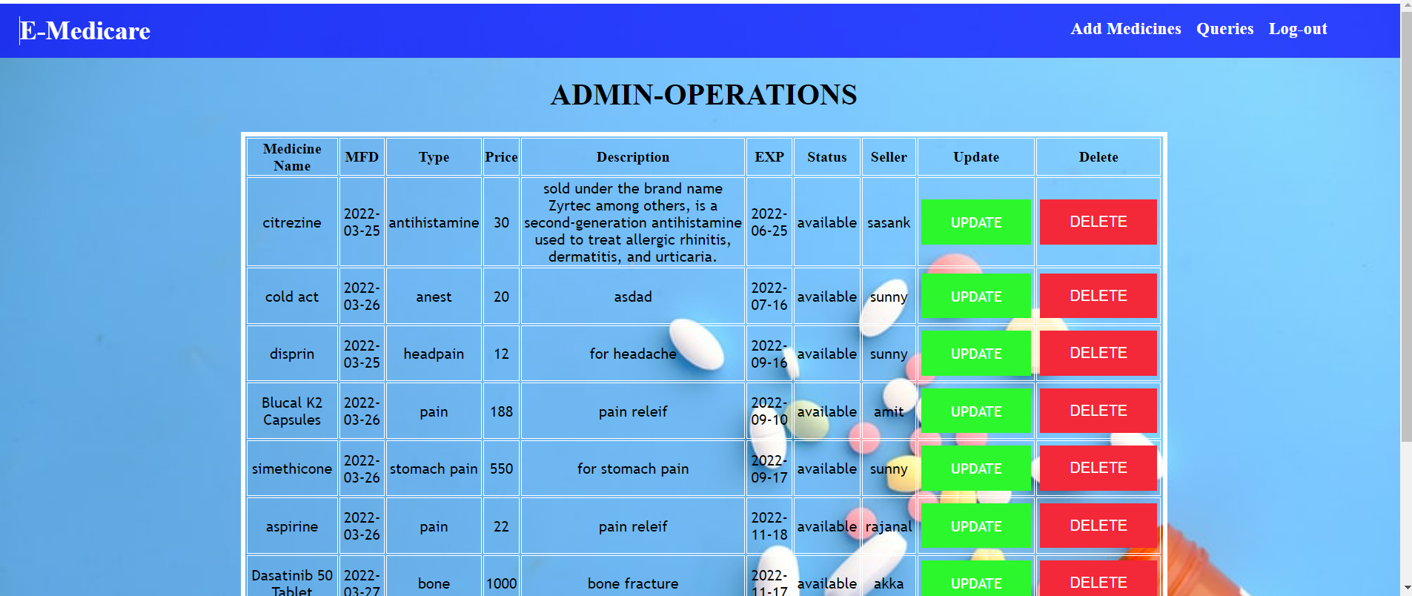

* 1. **Add product:**

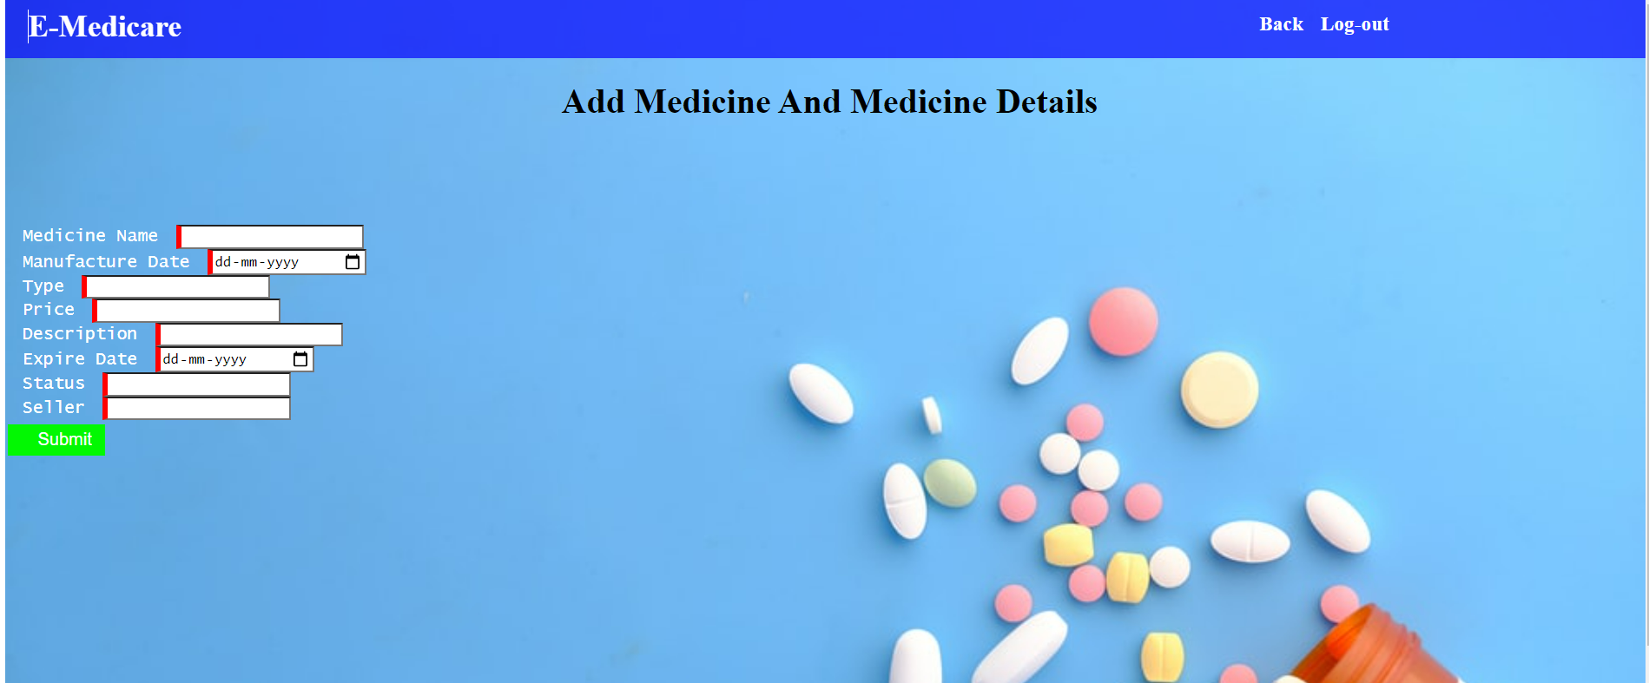

* 1. **User Registration page:**

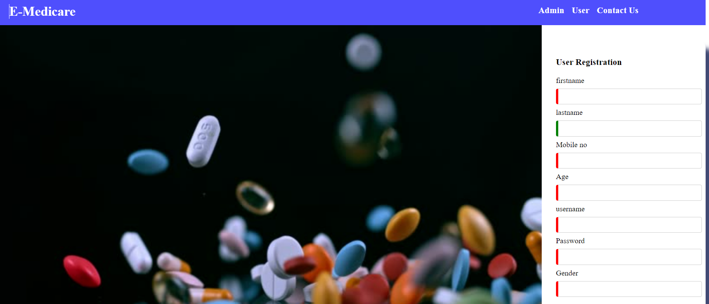

* 1. **Add to cart:**

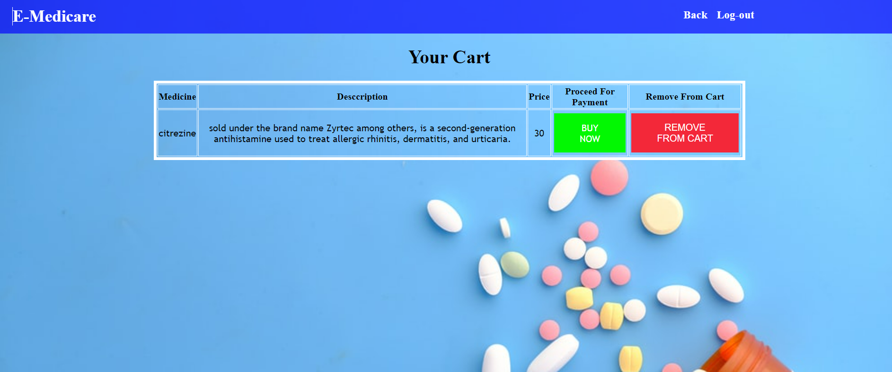

* 1. **Payment details:**

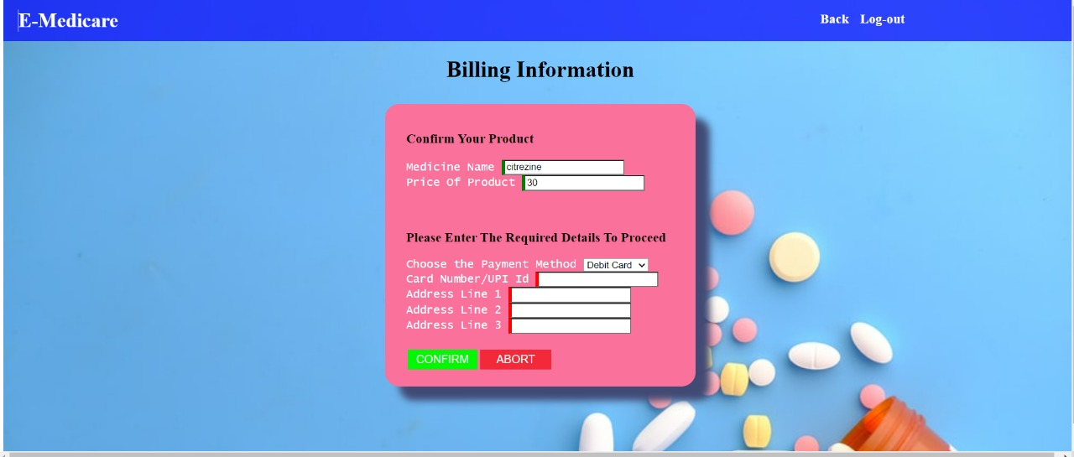

* 1. **Payment receipt:**

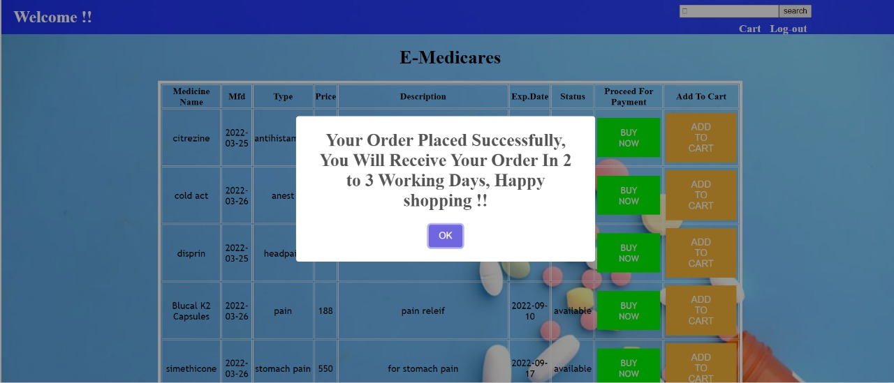

* 1. **Contact us:**

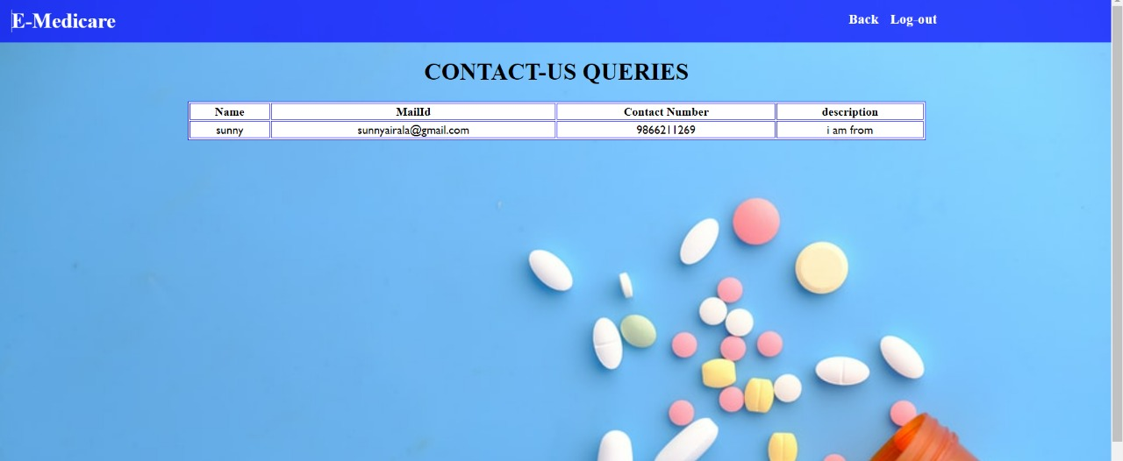

* 1. **Queries:**

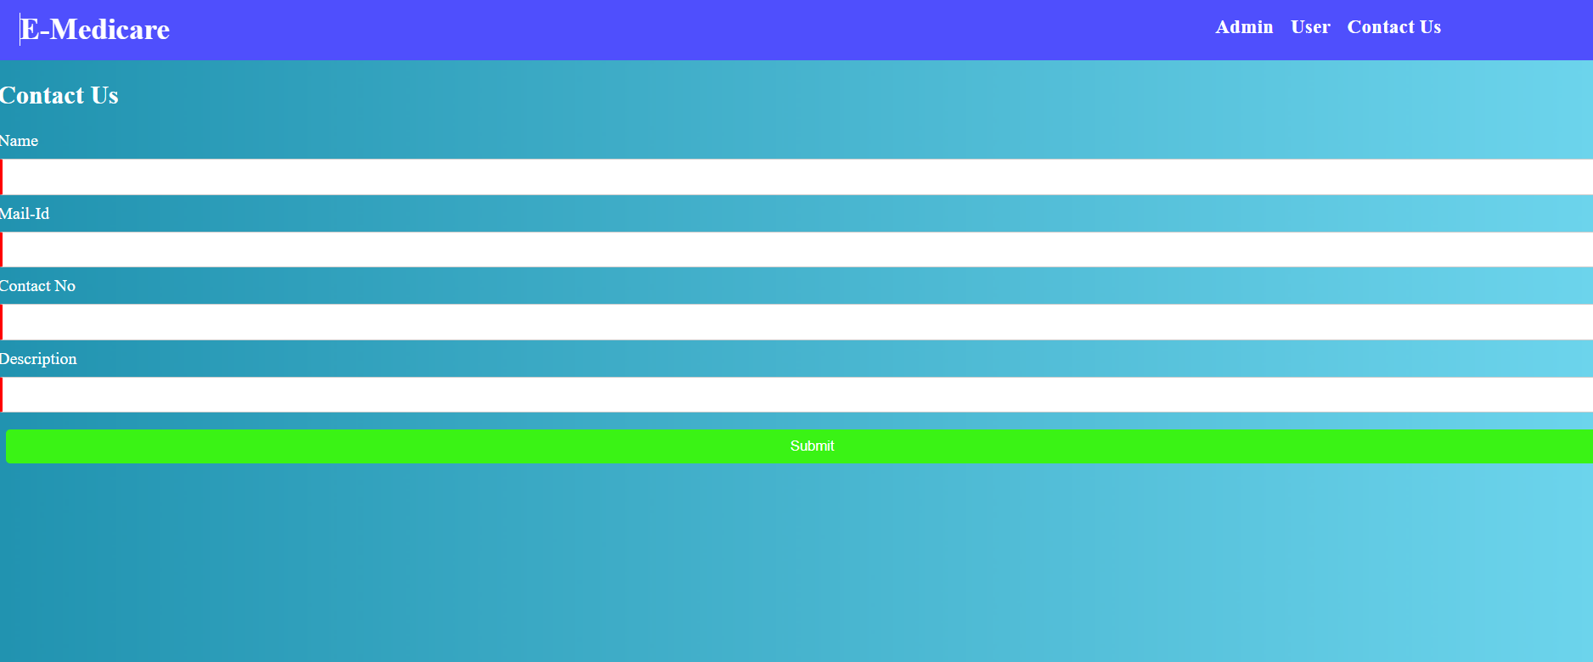

1. **CONCLUSION**

Our project is only a humble venture to satisfy the needs to manage their project work. Several user-friendly coding has also adopted. The objective of software planning is to provide a frame work that enables the manger to make reasonable estimates made within a limited time frame at the beginning of the software project and should be updated regularly as the project progresses.